Name: ____________________________ Class: ________ Date: ___________________
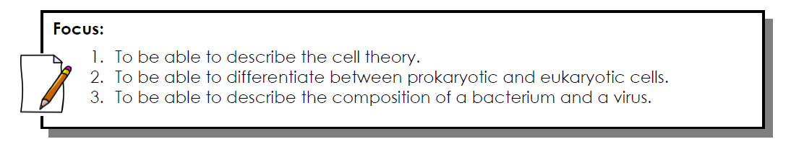
Cell Theory
- The cell is the _________________________________________ of life.
- All organisms are ______________________ of one or more cells.
- All cells ________________________________ other ________________.
Prokaryotic and Eukaryotic Cells
- Prokaryotic cells are cells whose organelles are ____________________________________ by a membrane.
- Eukaryotic cells are cells whose organelles are surrounded by ____________________________.
- Multicellular and a few unicellular organisms such as amoebas are composed of _________________________________________.
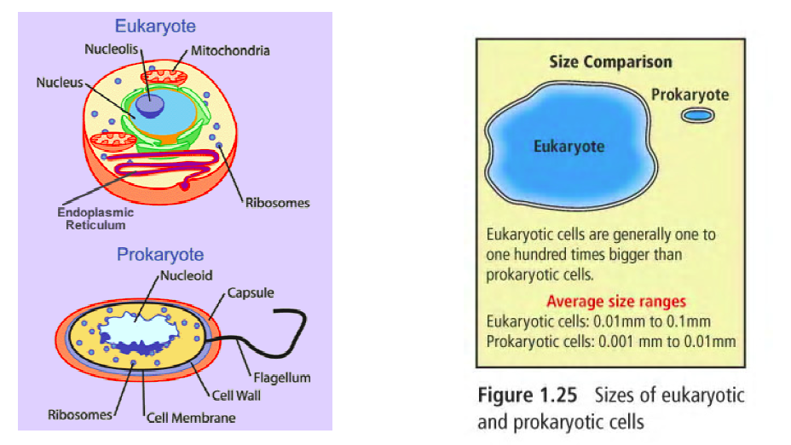

Bacteria / _________________________
- ____________________________ are prokaryotic cells.
- Some bacteria cause ___________________ such as tuberculosis and strep throat. The “super bug” is a bacterium highly resistant to antibiotics, found in hospitals.
- Some bacteria are ________________________, such as:
  - Bacteria in the digestive tract to aid in ________________________ of foods.
  - Bacteria used to produce __________________________________________________.
  - Bacteria used to produce ___________________________, such as insulin.
- Bacteria are classified by shape:
  - Cocci - ______________________ shaped
  - Bacilli - ______________________ shaped
  - Spirilla - _____________________ shaped
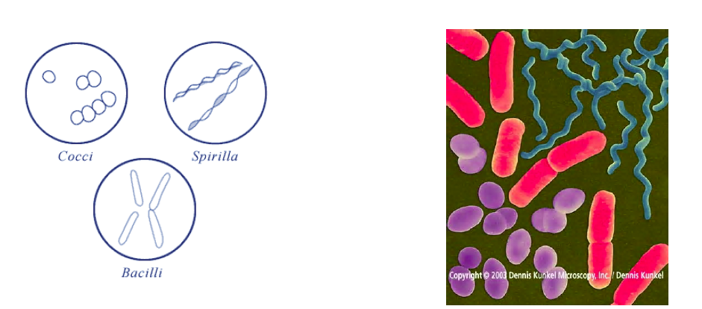
Viruses
- Viruses are tiny, non-living particles that reproduce only when they are inside a ____________________________.
- Viruses have ___________________________________________________________________.
It carries only the DNA needed to replicate itself.

