Name: | Class: | Date:

2.4 Improper Fractions and Mixed Numbers

Inquire:

- _______________________
- _______________________
- _______________________
- _______________________
- _______________________
- _______________________

- _________________________________________________________________

Notes:

- A mixed number is the sum of a _______________ number and a _______________.

- An improper fraction is a fraction where the ___________________ is greater than the ___________________.

Both represent a number that is ___________________ than a ___________________.

Converting between an improper fraction and a mixed number

Method: ______________________________________________________________________

Ex. Write 13/4 as
a mixed number

Converting between a mixed number and an improper fraction

Method: _____________________________________________________________________

Ex. Write 2 ½ as an
Improper fraction

Practice:

Express the following diagrams as both a mixed number and an improper fraction

1.
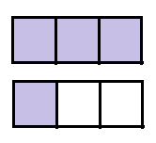

2.
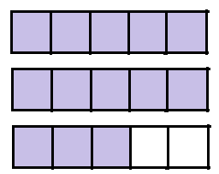

Convert the following mixed numbers to improper fractions

3. 4.

Convert the following improper fractions to mixed numbers

5. 6.

