Name: ______________________ Class: _______ Date: ________________
Focus:
To be able to describe the 3 lines of defense
To be able to differentiate between the acquired and innate immune response

The Immune The Immune System and Transmission of Infectious Diseases

- The immune system attacks and destroys invaders such as __________________________ and ____________________________ that enter the body.
- You can think of ______________________ and _______________________ as the “bad guys”
- Pathogens are organisms or substances that are ______________________________________.
  - Examples:

- Antigens are _____________________________________ that the body cannot recognize
  - Examples:
- Four ways to transmit infectious diseases:

- _____________________________________________

- _____________________________________________

- _____________________________________________

- _____________________________________________

Think-pair-share:
Describe some ways to prevent the transmission of infectious diseases and list them below:

The First Line of Defense
- The ______________ and _______________________________ of all internal organs is the first line of defense against pathogens.
- The skin is a ________________________ that prevents pathogens from entering the body.
- ________________________________________________________ on the skin prevent the growth of pathogens on your body.
- Acidic gastric juice in the digestive system can _____________________________________ that enter the stomach.
- ________________________________________________ that line the nose prevent pathogens from entering the respiratory tract.

The Second Line of Defense
- The body can mount an immune response called an ____________________________________ response, to attack and destroy _______________________________ that invades the body.

Innate Immune Responses:
- The innate immune response is quick and general, or ___________________________, usually against bacteria and some viruses.
- Fluid, white blood cells (__________________________), and dissolved substances from the blood move to the infected site.
- The above action causes ___________________________ and __________________________.
- Phagocytes _____________________________________________ invader cells.

The Third Line of Defense
- The body can mount an immune response called the ___________________________________ response, to attack and destroy ____________________________________ that enter the body.

Acquired Immune Response:
- The acquired immune response is a specific attack on a ________________________________ or _______________________.

Recognition: White blood cells ______________________________ and ___________________ _______________________. More T-cells are produced. Helper T-cells signal _______________.

- Mobilization: B-cells produce _______________________, specific particles created by the immune system to destroy specific disease-causing invaders.
- Disposal: Antibodies ________________________ pathogens.
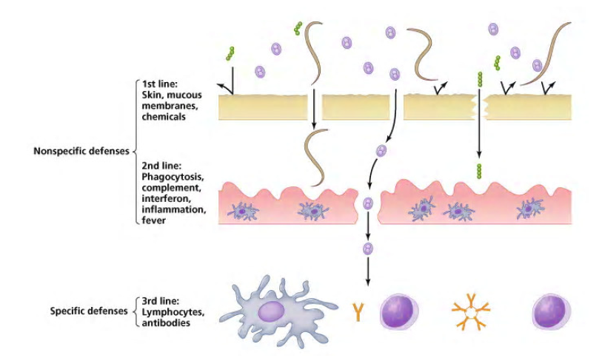
- Immunity: Some antibodies remain for future use.

A Historical Example:

