Goal • Determine the wavelengths of the colours of the spectrum.
What to Do
Fill in the colours of the spectrum in the diagram below. For help, refer to the chart on page 146 of BC Science 8.
DATE: | NAME: | CLASS:
CHAPTER 4 | ROY G BIV | BLM 2-5

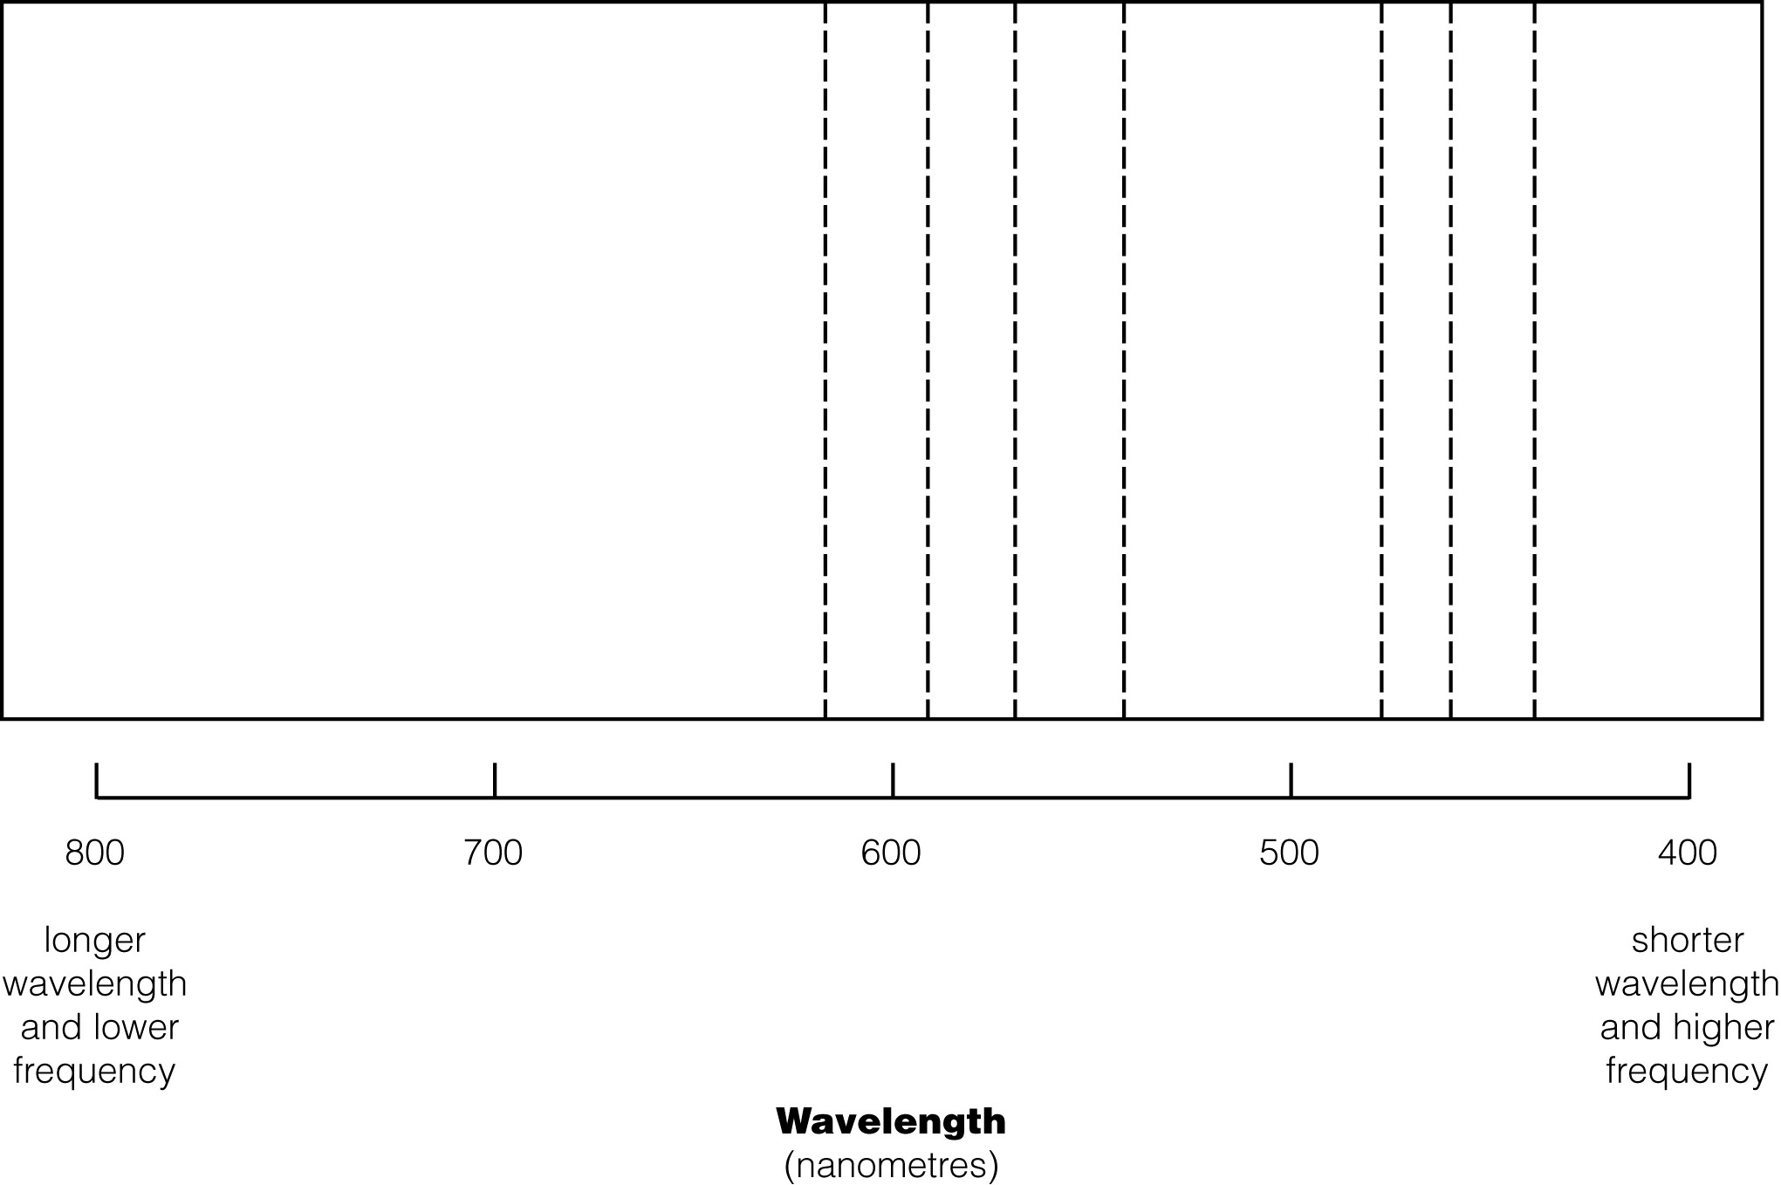

Copyright © 2006, McGraw-Hill Ryerson Limited, a Subsidiary of the McGraw-Hill Companies. All rights reserved.
This page may be reproduced for classroom use by the purchaser of this book without the written permission of the publisher.

