4.3 The Electromagnetic Spectrum of Light
Focus:
- To be able to describe the different types of radiation in terms of wavelength and frequency in relation to visible light
- To be able to provide examples of each type of radiation
The Electromagnetic Spectrum

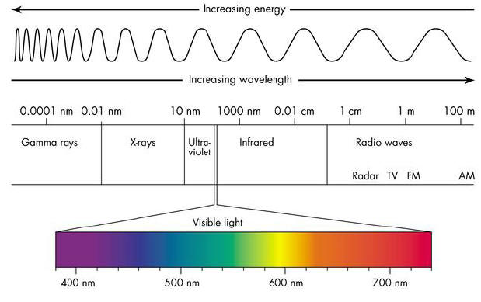
- Visible light is a tiny portion of a much larger range of _____________________________ called the electromagnetic spectrum.
- Visible light and invisible energy ________________ out from the sun and is called radiant energy.
- Electromagnetic radiation is the _________________________________ of energy in the form of waves that extend from the longest _________________________________________________ to the shortest __________________________________________________________________________.
- Radio waves, microwaves and infrared waves have wavelengths ___________________________ than visible light
- Ultraviolet waves, x-rays and gamma rays have ___________________________ wavelengths than visible light.

