Plane Mirrors

Plane mirrors: our brain knows that light travels in ______________________________. Therefore it makes it seem like the blueberry is ___________________ the mirror.

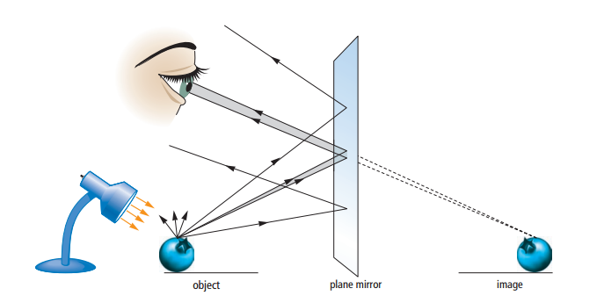



Image size and distance

* An image in a plane mirror is the ___________________________ as the bird, and both birds also appear to be the ____________________________________________ from the mirror.

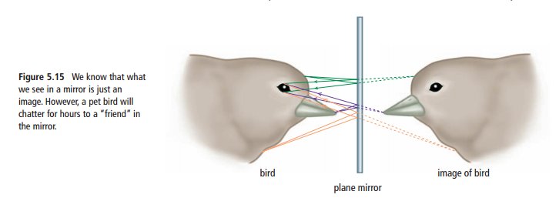

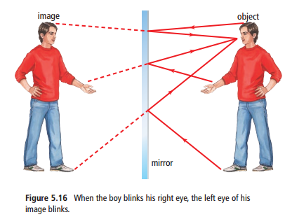Image Orientation

* Plane mirrors produce images that are _______________________
* However, left and right appear to be ________________________________ by a plane mirror.

Why do some mirrors make us look upside down?

Some mirrors are _________________________.

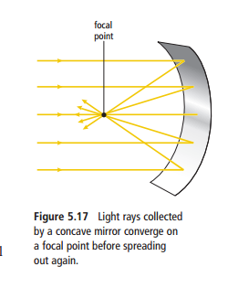

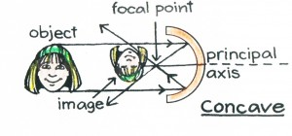You can see your image by looking at yourself in a spoon. The spoon acts like a **_______________,**which is a surface that **______________** (bounces back from a surface) light. The inside of the spoon’s bowl is **________________**, meaning it curves inward. When you look into a concave mirror, your image will be upside down.

The diagram shows how light is reflected from a concave mirror.

Uses of concave mirrors:

* Spotlights, ______________________, lighthouses, car headlights, ___________________
* _______________________ mirrors and ____________________ mirrors form an enlarged, upright image

|  |  |  |
| --- | --- | --- |
| Distance | Size of reflection | Orientation of reflection |
| Object is far away from concave mirror |  |  |
| Object is close to concave mirror |  |  |
| Object is very close to concave mirror |  |  |

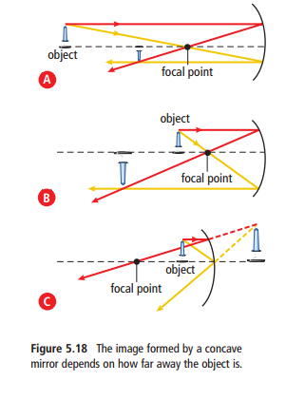

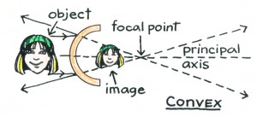Some mirrors are _______________________.

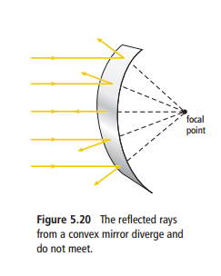

The outside of a spoon’s bowl is **______________**, meaning it curves _________________. When you look into a convex mirror, your image will be ____________ side up. The diagram shows how light is reflected from a convex mirror. Notice that this surface makes the image seem to appear ______________ the mirrored surface. Note how much ______________ the image is.

Characteristics of convex mirrors:

1. Objects appear to be __________________ than they really are.
2. _____________________ can be seen in a convex mirror than in a plane mirror of the same size.

Uses of convex mirrors:

* _______________________ mirrors
* ________________________ and ___________________________ mirrors in cars

**DISCOVER FOR YOURSELF**

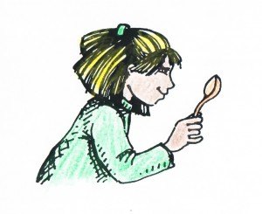Determine the effect of curved mirrors on the image they produce by looking at a large metal spoon. Hold the spoon with the inside of the bowl facing you. Move the spoon back and forth from your face until the clearest image is formed. You should see an upside down image.

Turn the spoon around so that you look at the outside of the bowl. Again, move the spoon back and forth from your face until the clearest image is formed. You should see a right side up image.