Goal • Decipher reflected images to review the laws of reflection.
What to Do
Use a mirror to read the three messages below. Then answer the following questions.

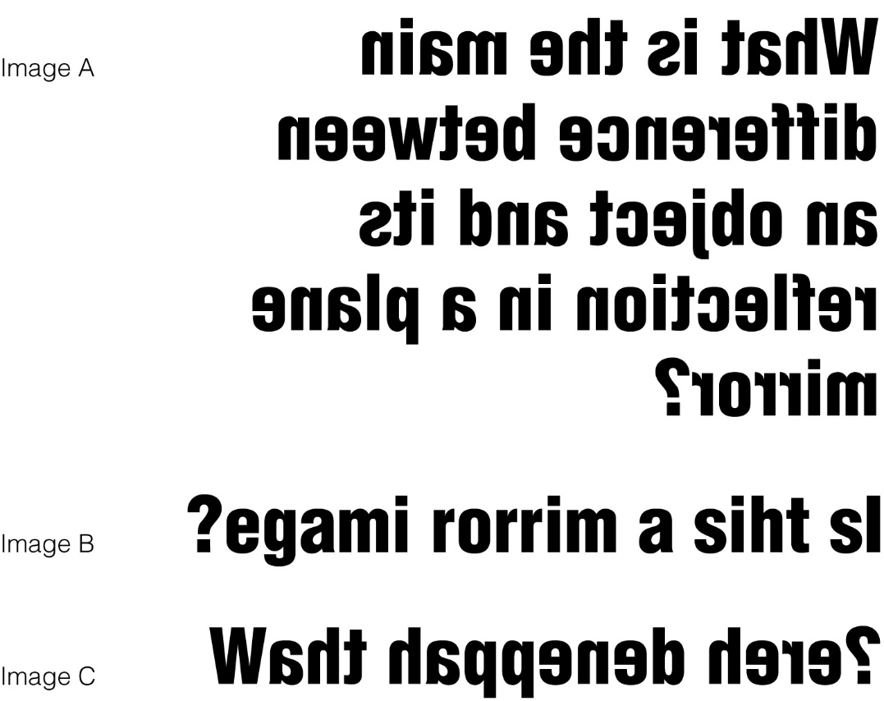

1. Which of these images is a true reflection in a plane mirror?
________________________________________________________

2. How were the other images made?
________________________________________________________
________________________________________________________

3. Consider all of the letters of the alphabet. What capital letters look the same when they are reflected in a mirror?
________________________________________________________

