Goal • Use this page to reinforce your knowledge of the principles of reflection.
What to Do
1. Use a ruler to draw the reflected images of the objects below.

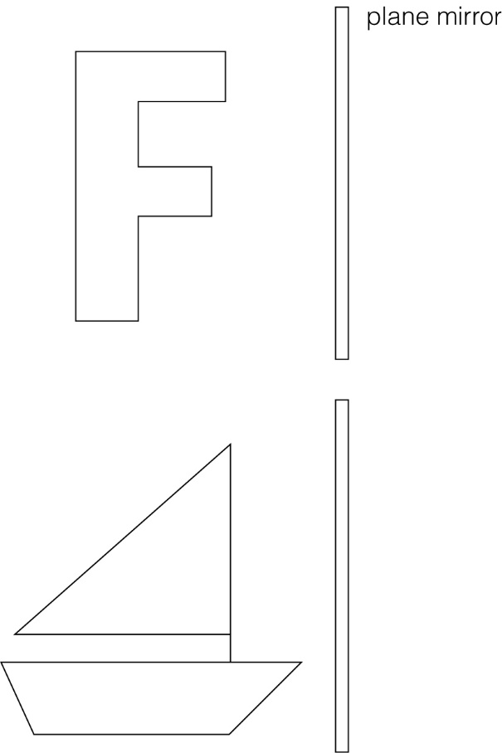

2. Were there any differences between the object and its image in the plane mirror
with respect to:
(a) size?
F _______________________ Sailboat _________________________
(b) distance from the mirror?
F _______________________ Sailboat _________________________
(c) orientation?
F _______________________ Sailboat _________________________

