Name: | Class: | Date:

8.1 and 8.2: Introduction to Circles

Using your textbook, define the following terms:

Radius: _______________________________________________________________________
____________________________________________________________________________________________________________________________________________________________

Diameter: _____________________________________________________________________
____________________________________________________________________________________________________________________________________________________________

Practice: For each circle, identify the radii, (plural for radius), and the diameter. Example: in 1 MO is one of the circle’s radii, (the centre letter is always written first)

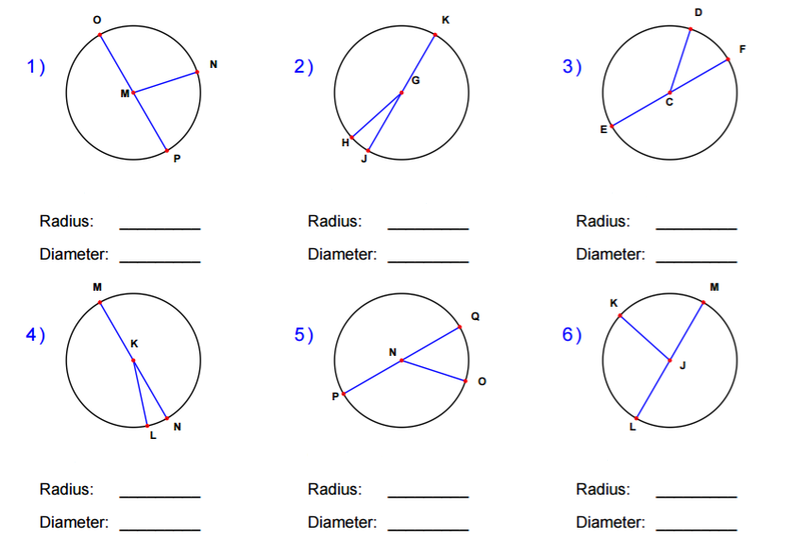

Circumference: _________________________________________________________________
____________________________________________________________________________________________________________________________________________________________

Activity: How does the circumference of a circle relate to its diameter?
Using ruler and some string, fill in the table below for the circles on the page of circles and other classroom objects.

Circle/Object | Circumference, C (cm) | Diameter, d  (cm) | Circumference ÷ Diameter

pi: ___________________________________________________________________________
____________________________________________________________________________________________________________________________________________________________

Calculate the circumference for the following circle:

