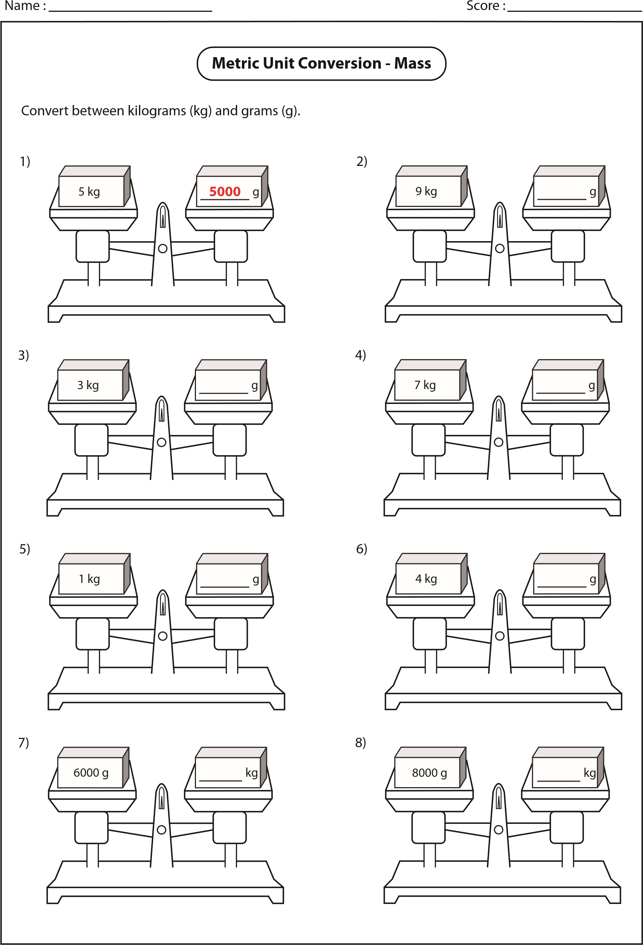

Name :

Score :

Convert the following grams (g) to kilograms (kg).

Convert the following kilograms (kg) to grams (g).

1)

2)

3)

4)

5)

6)

7)

8)

9)

10)

11)

12)

13)

14)

15)

16)

Example 1 :

Example 2 :

g

27.89

kg

=

=

kg

24280

g

kg

=

54300

g

kg

=

g

8000

g

=

kg

62132

=

43510

g

kg

=

g

10340

kg

g

24100

=

kg

g

=

35.2

kg

g

70.43

kg

=

g

kg

=

41.236

g

13

kg

=

g

65.5

kg

=

g

kg

=

50.01

g

82.8

kg

=

46500

=

kg

g

**1000**

**grams = 1 kilogram**

g

=

46500

46500

1000

**=**

**46.5**

**kg**

g

=

kg

46.5

**kilogram = 1000 grams**

**1**

kg = 46.5 ×

1000

46.5

**=**

**46500**

**g**

kg

70263

=

g

**Metric Unit Conversion - Mass**