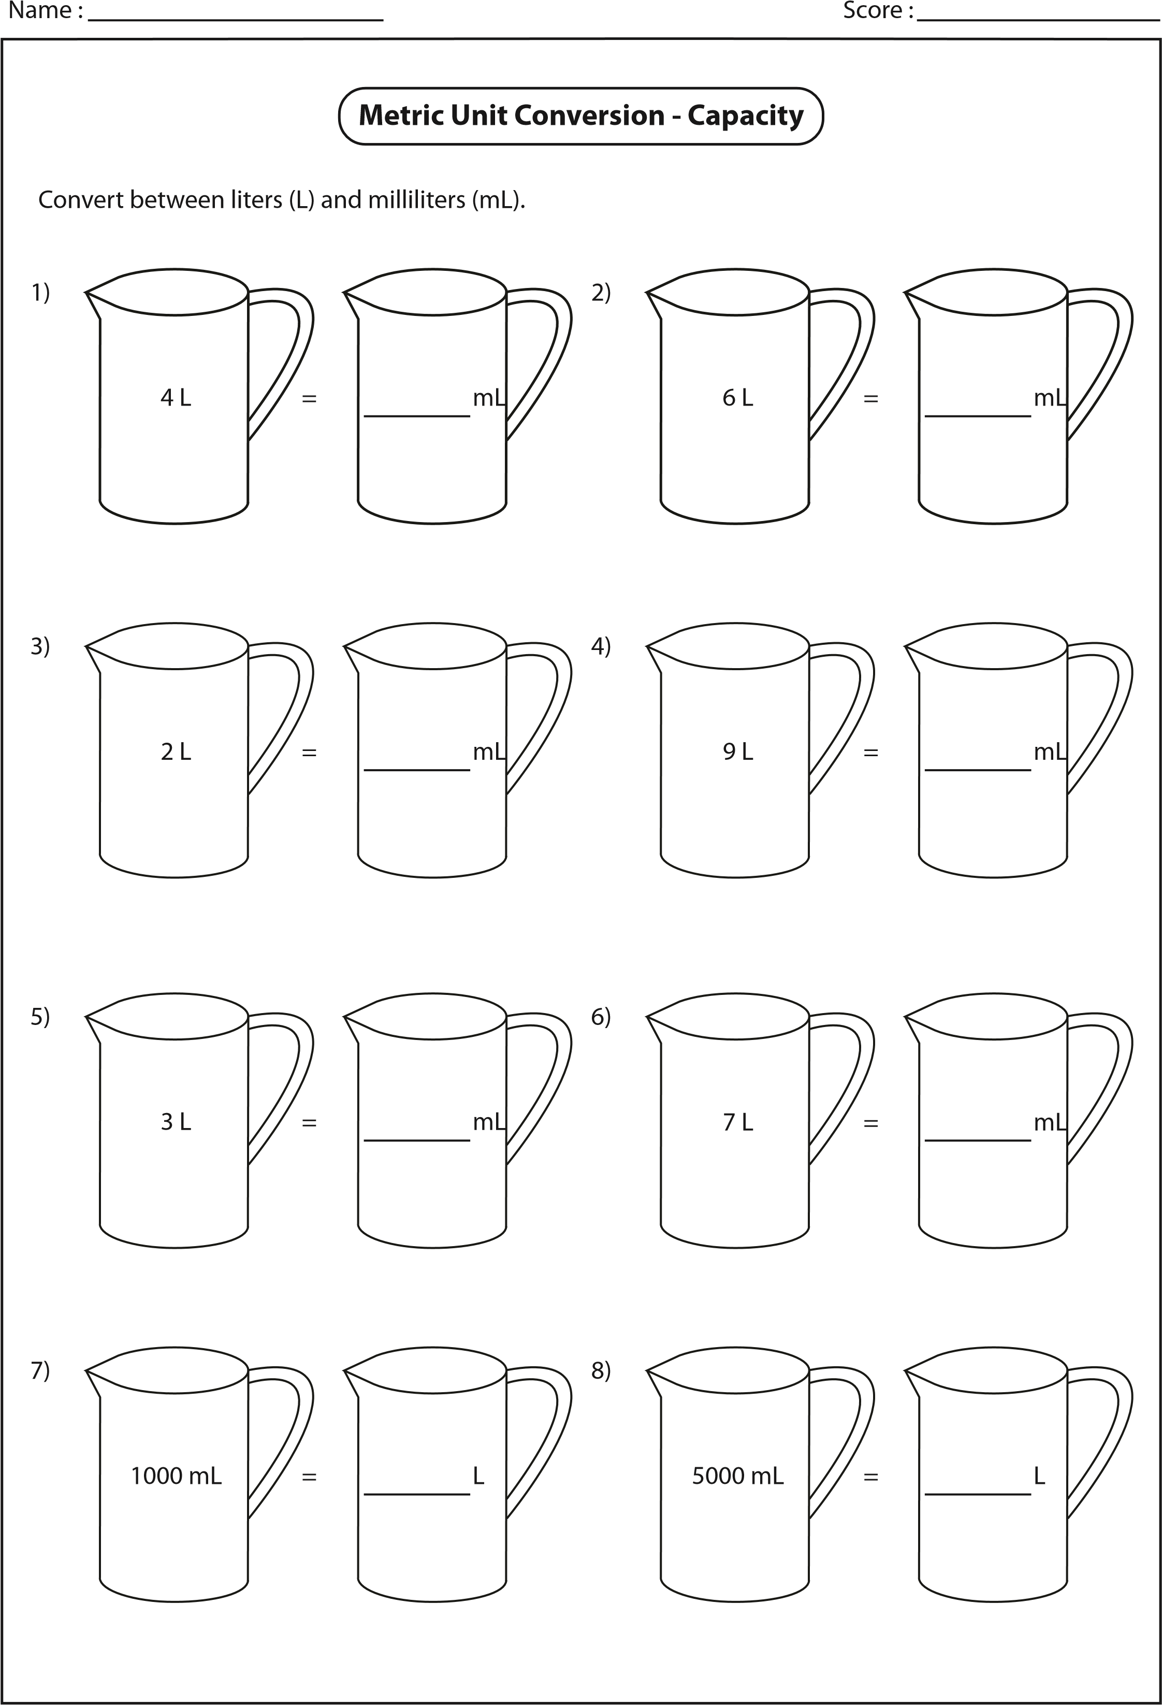

Name :

Score :

Convert the following liters (L) to milliliters (mL).

Convert the following milliliters (mL) to liters (L).

1)

2)

3)

4)

5)

6)

7)

8)

9)

10)

11)

12)

13)

14)

15)

16)

Example 1 :

Example 2 :

L

48190

mL

=

mL

L

16

=

23.27

L

=

56.6

L

mL

=

L

17.412

mL

=

76.52

mL

=

L

mL

=

L

35.53

L

=

91.6

mL

L

=

32780

mL

L

mL

=

67900

L

=

5000

mL

L

21156

mL

=

L

=

mL

89300

L

mL

=

53600

L

mL

93200

=

mL

=

L

23700

**milliliters = 1 liter**

**1000**

mL

23700

=

23700

1000

**=**

**23.7**

**L**

=

L

47.8

mL

mL

=

L

23.7

**1**

**liter = 1000 milliliters**

23.7

L

=

23.7

×

1000

**=**

**23700**

**mL**

mL

**Metric Unit Conversion - Capacity**