Name: _____________________________ Class: _________ Date: ____________________

Integer Notes:

Integers are __________________ numbers that can be either __________________ than or __________________ than __________________. This means that integers can be __________________ and __________________.

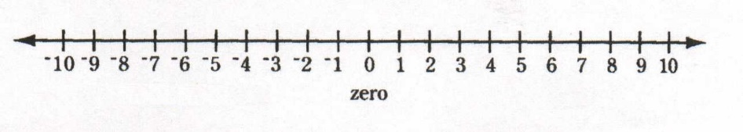

Rules Adding Integers:

When you are adding two integers with the__________________ __________________, you
_____________________________________________________________________________.

Example:

(+4) + (+15) =

When you are adding integers with __________________ __________________, you
___________________________________________________________________________________________________________________________________________________________.

Example:

(+25) + (-44) =

Rule for Subtracting Integers:

When you are subtracting integers, you are actually ___________________________________
_____________________________________________________________________________.

Example:

(+7) - (+16) =

(+27) - (-45) =

