Eukaryotic Cells

Goal • Compare and contrast a prokaryotic cell and a eukaryotic cell.
What to Do
Use the Venn diagram below to compare and contrast a prokaryotic cell and a eukaryotic cell.

DATE: | NAME: | CLASS:
CHAPTER 1 | Comparing Prokaryotic and | BLM 1-21
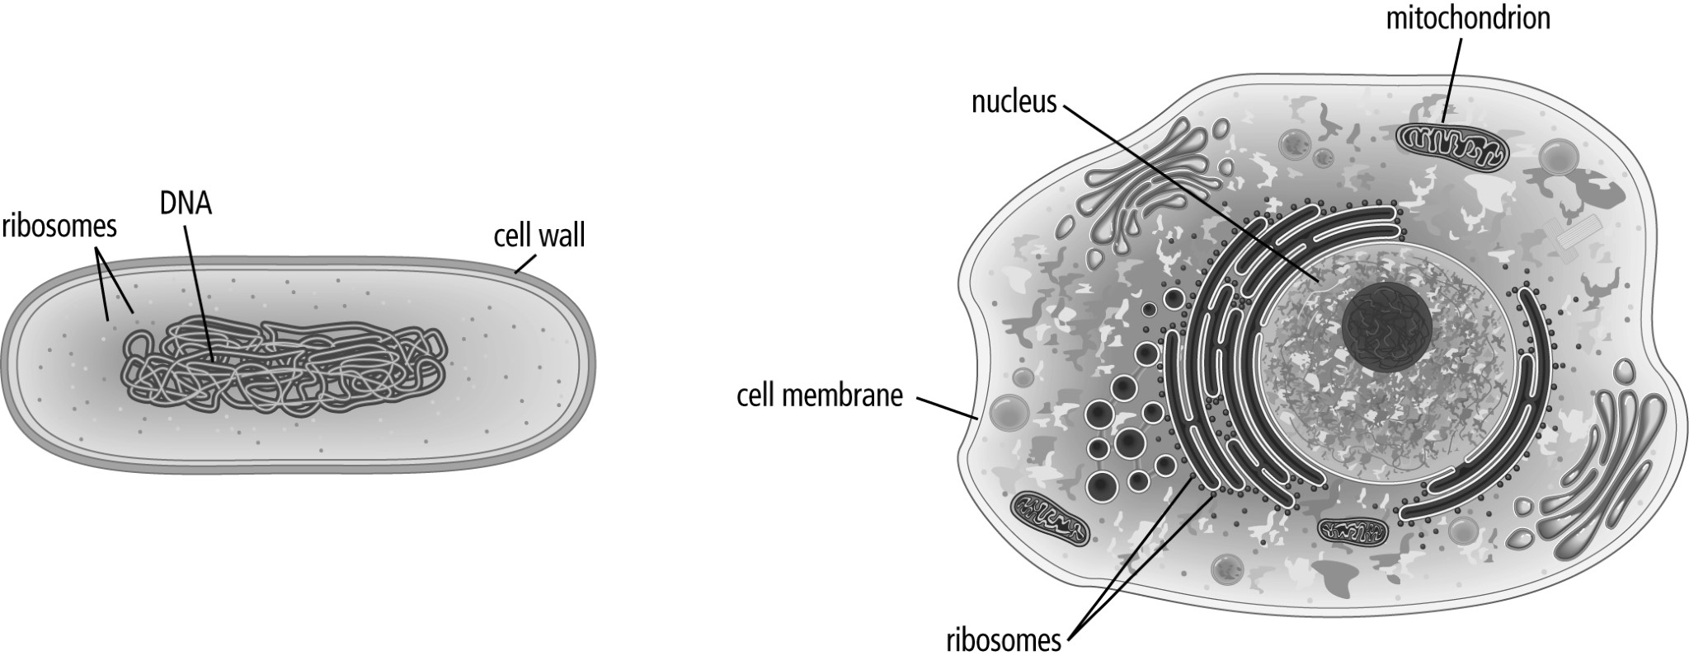
Prokaryotic Cell Eukaryotic Cell
