Name: | Class: | Date:

Science 8 – Unit A Review: Biology

Use your textbook and notebook to help you answer the questions in this review package.

  - Observing Living Things

1. Name five characteristics of living things
a. ________________________________________________________________________
b. ________________________________________________________________________
c. ________________________________________________________________________
d. ________________________________________________________________________
e. ________________________________________________________________________

1.2 Cells
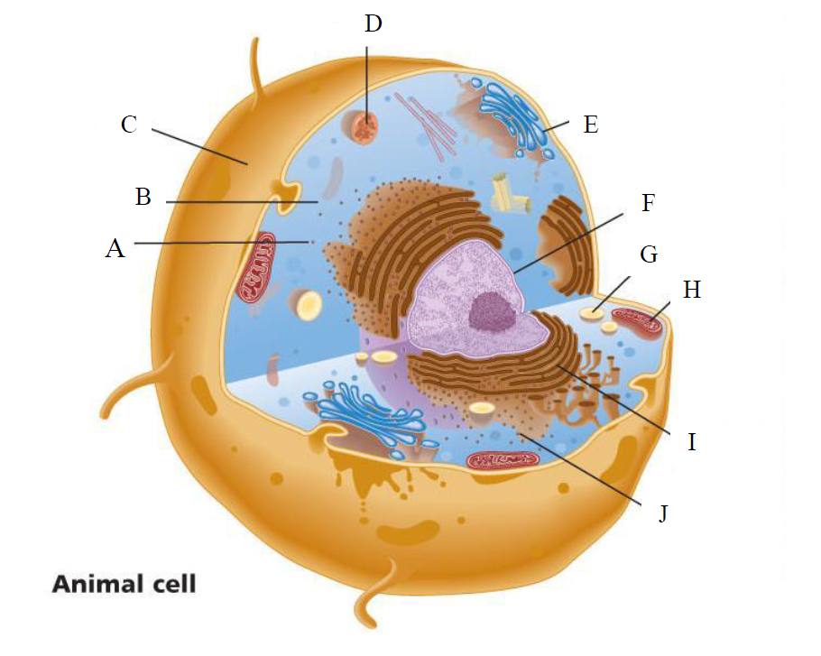

1. Identify each part of the animal cell and describe its function.

A. Part: ___________________________________________________________________
Function: _______________________________________________________________
_______________________________________________________________________

B. Part: ___________________________________________________________________
Function: _______________________________________________________________
_______________________________________________________________________

C. Part: ___________________________________________________________________
Function: _______________________________________________________________
_______________________________________________________________________

D. Part: ___________________________________________________________________
Function: _______________________________________________________________
_______________________________________________________________________

E. Part: ___________________________________________________________________
Function: _______________________________________________________________
_______________________________________________________________________

F. Part: ___________________________________________________________________
Function: _______________________________________________________________
_______________________________________________________________________

G. Part: ___________________________________________________________________
Function: _______________________________________________________________
_______________________________________________________________________
H. Part: ___________________________________________________________________
Function: _______________________________________________________________
_______________________________________________________________________

I. Part: ___________________________________________________________________
Function: _______________________________________________________________
_______________________________________________________________________

J. Part: ___________________________________________________________________
Function: _______________________________________________________________
_______________________________________________________________________

2. Identify each part of the plant cell and describe its function.
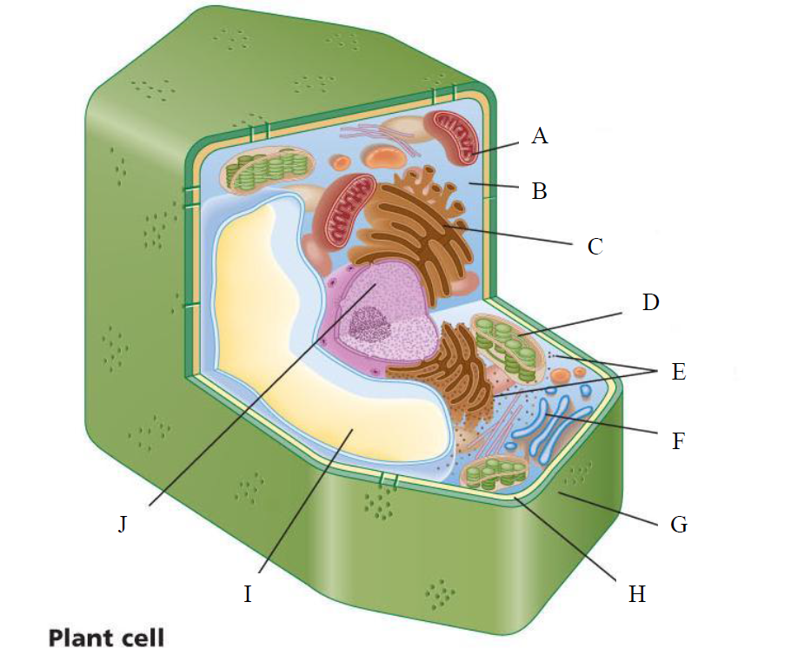

A. Part: ___________________________________________________________________
Function: _______________________________________________________________
_______________________________________________________________________

B. Part: ___________________________________________________________________
Function: _______________________________________________________________
_______________________________________________________________________

C. Part: ___________________________________________________________________
Function: _______________________________________________________________
_______________________________________________________________________

D. Part: ___________________________________________________________________
Function: _______________________________________________________________
_______________________________________________________________________

E. Part: ___________________________________________________________________
Function: _______________________________________________________________
_______________________________________________________________________

F. Part: ___________________________________________________________________
Function: _______________________________________________________________
_______________________________________________________________________

G. Part: ___________________________________________________________________
Function: _______________________________________________________________
_______________________________________________________________________
H. Part: ___________________________________________________________________
Function: _______________________________________________________________
_______________________________________________________________________

I. Part: ___________________________________________________________________
Function: _______________________________________________________________
_______________________________________________________________________

J. Part: ___________________________________________________________________
Function: _______________________________________________________________
_______________________________________________________________________

3. What is the difference between a plant cell and an animal cell?
______________________________________________________________________________
____________________________________________________________________________________________________________________________________________________________

4. What are the three parts of the cell theory?
______________________________________________________________________________
____________________________________________________________________________________________________________________________________________________________

5. What is the difference between a prokaryotic and eukaryotic cell?
______________________________________________________________________________
____________________________________________________________________________________________________________________________________________________________

  - Diffusion, Osmosis, and the Cell Membrane

1. What is the difference between diffusion and osmosis? Give an example of diffusion.
______________________________________________________________________________
__________________________________________________________________________________________________________________________________________________________________________________________________________________________________________

3.1 The Immune System

1. What is the purpose of the immune system? (see pp. 56-57 from the textbook)
______________________________________________________________________________
______________________________________________________________________________

2. List the four ways to transmit infectious disease?
________________________________________________________________________________________________________________________________________________________________________________________________________________________________________________________________________________________________________________________

3. What is the difference between an innate immune response and an acquired immune response?
______________________________________________________________________________
__________________________________________________________________________________________________________________________________________________________________________________________________________________________________________

4. In an acquired response, what is the role of the:

a. B cells _______________________________________________________________
________________________________________________________________________

b. T cells _______________________________________________________________
________________________________________________________________________

3.2 Factors Affecting the Immune System

1. What is a vaccine?
__________________________________________________________________________________________________________________________________________________________________________________________________________________________________________

2. What is an allergy?
__________________________________________________________________________________________________________________________________________________________________________________________________________________________________________

3. What virus causes AIDS and what does this virus do in your body?
__________________________________________________________________________________________________________________________________________________________________________________________________________________________________________

