Name: ________________________ Class: _______ Date: ________________

Microscope Diagram:

- Label the following parts of a compound light microscope.

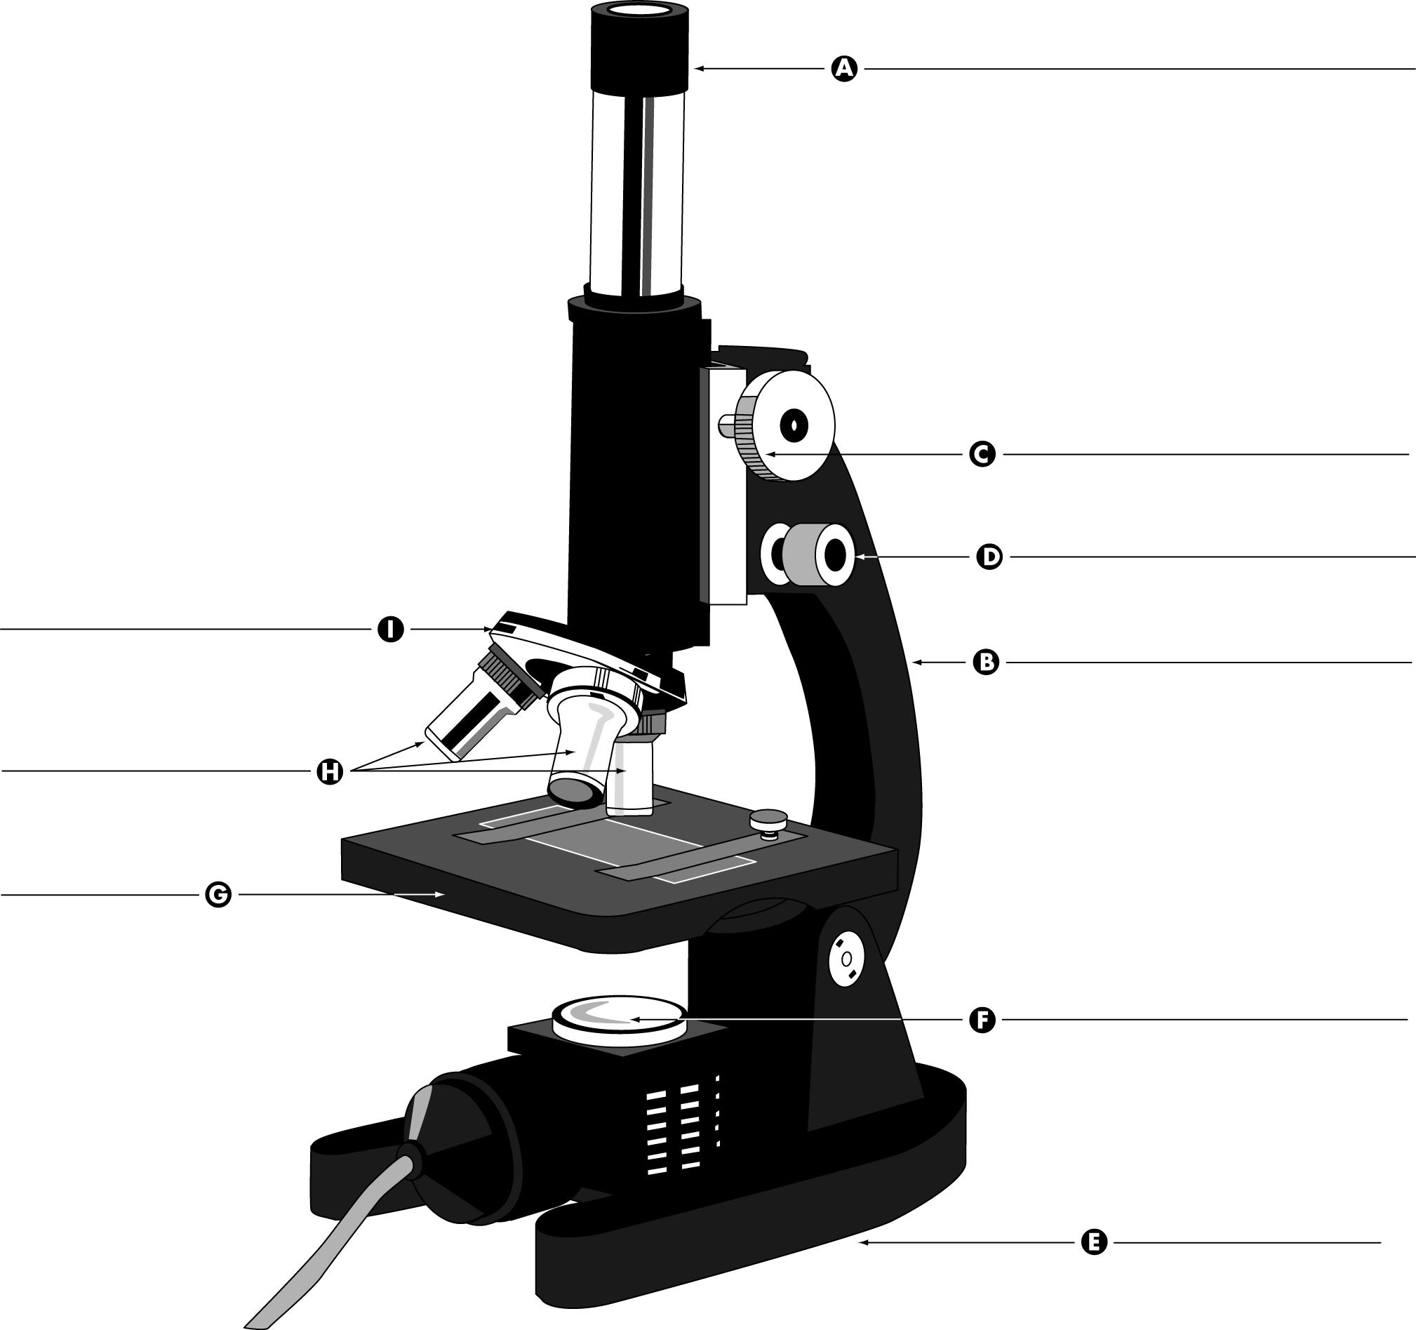
Quiz next class!

Things you need to know:

- What are the 5 characteristics of living things?
- Be able to label all the parts of a compound light microscope. You will be given the same diagram used on the back of this page.
- Be able to calculate the total magnification of a microscope under low, medium, and high power.

