Name: ______________________________ Class: ____________ Date: _______________________

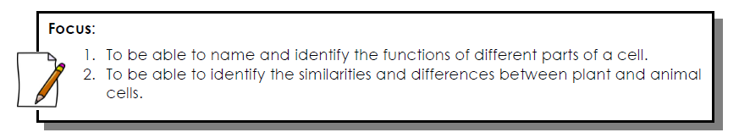

Cell Structures

- Organelles are _____________________ inside a cell in which functions are carried out to ensure the cells ___________________________ (work properly)
- The cell _____________________________ is a structure that surrounds the cells and separates the cells interior from its surroundings. This protective barrier controls the ______________ of materials into and out of the cell.
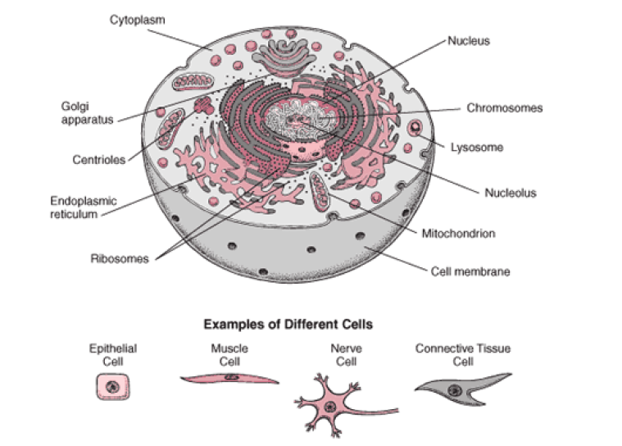
Organelles
- Cytoplasm is a ______________-like substance that contains organelles, water, and other life-supporting materials.
- The ___________________ is the organelle that controls all the activities within the cell. It contains _____________________________________________, DNA, the hereditary material that is passed on to offspring.
- Mitochondria are the energy producers in the cell. Energy is released from the food we eat by the process of ________________________________________________________________.
- Ribosomes manufacture _____________________, the building blocks for a variety of structures in the cell. Some are found in the cytoplasm and others are attached to the endoplasmic reticulum.
- Endoplasmic reticulum is a network of folded channels that ______________________ materials within the cell.
- ____________________ body is a structure that sorts and packages the proteins in membrane-wrapped structures called ___________________.
- ______________________ are small packages carrying proteins, nutrients, and water. They carry water inside, outside, and all around the cell.
- Vacuoles are _____________________ storage containers. These tend to be larger in plant cells than in animal cells.
- Lysosomes contain digestive ___________________ that break down food particles, cell wastes and worn-our cell parts.

Think-pair-share:
Compare the parts of the cell and their functions to the parts of a school and its functions
School | Cell | Function
 | Cell Membrane
 | Cytoplasm
 | Nucleus
 | Mitochondria
 | Ribosome
 | Endoplasmic Reticulum
 | Golgi Body
 | Vesicles
 | Vacuoles
 | Lysosome

Difference between Plant and Animal Cells

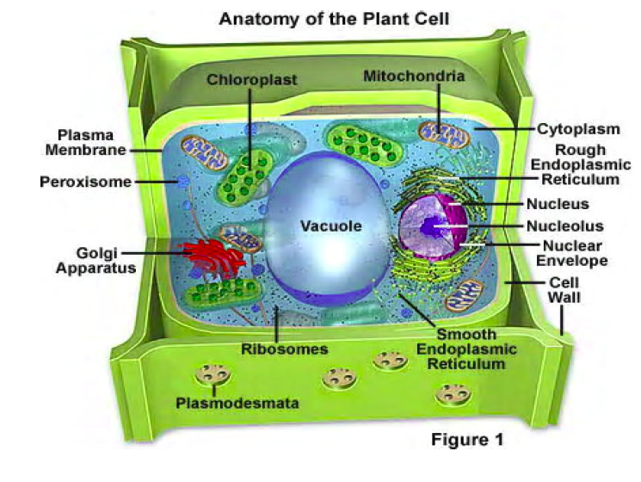

- Two parts found in the plant cell but not in the animal cell are:
  - ___________________________________________
  - ___________________________________________
- The _________________________ is a rigid structure that surrounds the cell membrane to provide support and protection to the box-shaped plant cell.
- ______________________________ trap energy from the sun and change it into chemical energy the plant can use.
- ______________________________ is the chemical reaction that takes place when carbon dioxide and water react in the presence of sunlight to produce ________________________ and ________________________.

