Name: ________________________ Class: _______ Date: ______________________
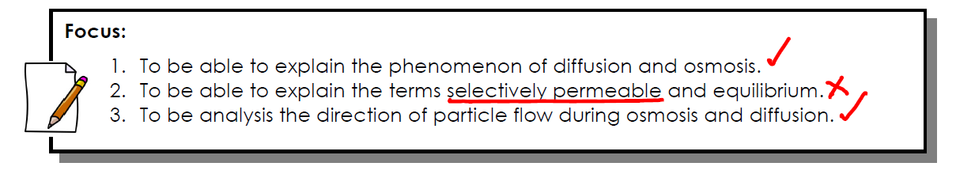

Think-pair-share:
List 2 things you think should be able to move into a cell and 2 things you think should not be able to move into a cell. Explain your choice.
Able to move in a cell | Not able to move in a cell

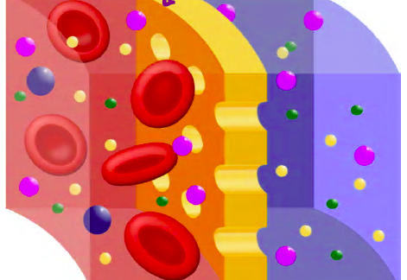
Cell Membrane
- The cell membrane is ______________________________________. This means that it allows some substances to _______________ through but not others.

Diffusion
- Diffusion happens when particles more from an area of __________ concentration to an area of _____________ concentration.

- Concentration is the amount of _______________________ in a certain place. A place of higher concentration has more particles than a place of lower concentration.

- As particles move, a state of balance called ________________________ will eventually be reached. Particles will still ________________________________, but the rates of movement _________________________________ are ___________________________.

- Diffusion moves _______________________________ from outside the cell to inside the cell.
- Diffusion moves __________________ from inside the cell to outside the cell.

Osmosis
- Osmosis is the diffusion of ______________________________ through a selectively permeable membrane. This happens when water moves from an area of ___________ concentration to an area of low concentration through a ________________________________________________.
- The process of ___________________________________ occurs when water moves from an area of __________________ concentration to an area of higher concentration across a selectively permeable membrane. ____________________________________ must be used for this to occur.
Think-pair-share:
If the concentration of water outside the cell is higher than it is inside the cell, in which direction will water move?
