Name: | Class: | Date:

10.3 Evaluating Expressions

In math, “evaluate” means _______________________________________________________

There are times when you will be given an expression and asked to evaluate it given the value of the variable(s) within it

For example – Solve the following expression (2y + 4) if:

- y = 1

- y = 3

Sometimes, you are asked to create a table of values using an expression such as the example on page 367.

Show You Know. Complete the practise question on the bottom of page 367

- How many line segments are in Figure 12 of this pattern?

10.4 Graphing Linear Equations

A linear relation is a ________________ made by ________________________________ that results in ________________________________________________ on a _________________ __________________.

A graph is a visual way to show how ________________________________________________ _____________________________.

Show You Know:
- Imagine that for every pup in a cup, there are four fish at the store. Complete the table:

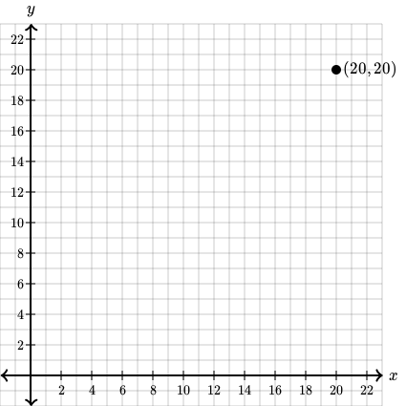
Number of Pups, p | Number of Fish, f | Ordered Pair (p, f)
1 | 4
2 | 8
3 | 12
4
5

- Graph the ordered pairs

- Describe the pattern of points on your graph with:

- Words

- Distances on a graph

- A relationship

