Properties of Visible Light
Focus:
- To be able to describe the wave model of light
- To be able to compare and contrast refraction and reflection
- To be able to rationalize how colours are produced
- Light is a type of wave that travels through empty _________________ and transfers energy from place to place, such as Sun to Earth.
- Visible light is made up of waves of different _____________________, each with their own wavelengths and frequencies.
- When light passes from one __________________________________ to another, the wave will bend or refract.
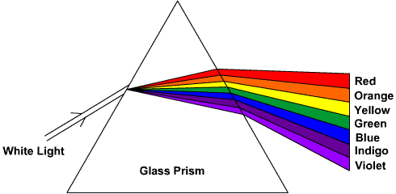
- Different wavelengths of light will ___________________________ by different amounts. A prism refracts white light, _________________________________ the colours. A second prism can _____________________ the colours to form white light.

- The range of colours or frequencies of light is called the ___________________ spectrum

(ROY G BIV)
- Reflection occurs when a light wave strikes an object and ___________________ off.
- An object appears red because it reflects red light and absorbs __________________________
- The three additive primary colours of light are red, green, and blue. These 3 colours make all the colours of the rainbow and are combined to make _______________________ light.

