Ray Model of Light
Focus:
- To be able to explain the ray model of light
- To be able to differentiate among transparent, translucent, and opaque objects
- To be able to understand and draw ray diagrams to represent reflection and refraction
- Light rays travel in _____________________ lines. A light ray is illustrated as a straight line with an ___________________ to indicate the direction that the light wave travels.
- Transparent objects will ______________________ light, allowing light to pass through.
- Translucent objects will allow light to pass through but will _________________ light rays in all directions.
- Opaque objects ____________________ light from passing through it. Light rays will be reflected or ___________________________.
- Shadows demonstrate how light rays travel in _________________________ lines.
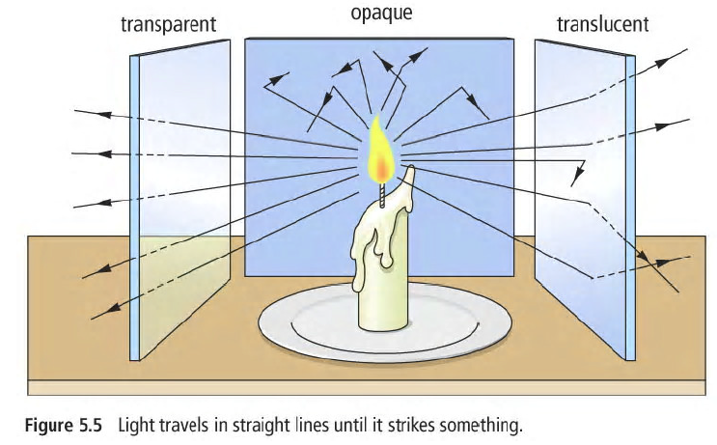
Reflection
- Reflection occurs when light rays strike a _____________________ object and bounce off.
- The Law of Reflection states that the angle of reflection is ____________________ to the angle of incidence
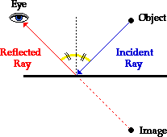
- Note that angles are always measured from the __________________________ line to the ray
- The normal is a line drawn ___________________________________ to the mirror (boundary) at the point of incident.

Refraction
- Light is bent, or refracted, as it changes __________________, passing from one medium to another.
- The angle of refraction (R) is the angle of a light ray ___________________________ from a material, measured between the normal and the refracted ray.
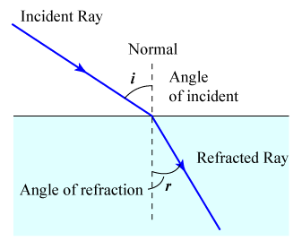

Light rays from the object bend away from the normal as they pass from water to air. Objects appear closer to the surface than they really are.

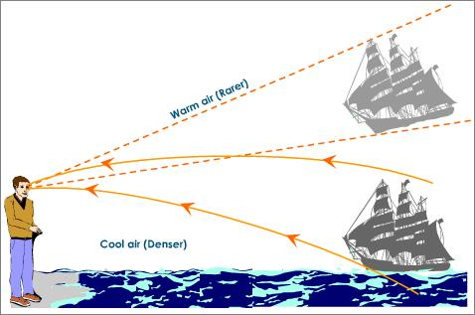
- A mirage is an _____________________________ caused by the refraction of light through air.

