Name Date

Applying Knowledge

Section 5.1

*Use with textbook pages 169–170.*

# Getting in light’s way

### Complete the table and diagram below.

1. Complete the following table.

|  |  |  |
| --- | --- | --- |
| **Materials** | **What happens when light strikes this material?** | **Examples of materials** |
| **transparent** |  |  |
| **translucent** |  |  |
| **opaque** |  |  |

1. State whether light is mostly absorbed, reflected, transmitted, or scattered by each object.

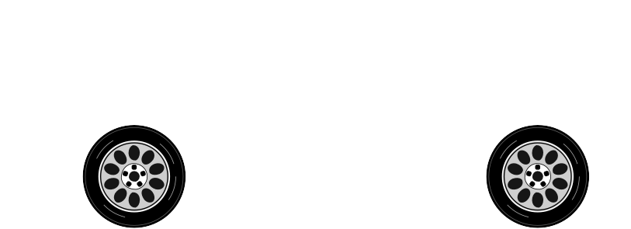

* 1. cloud 2. yellow traffic light
     1. white car



* + 1. black tire
    2. clear glass window

Name Date

Illustrating Concepts

Section 5.1

*Use with textbook pages 172–175.*

# Predictable behaviour of light

### Complete the diagrams below.

1. Draw the light rays that result when light rays strike a transparent surface.



1. Draw the light rays that result when light rays strike a translucent surface.

clear glass

waxed paper

1. Draw the light rays that result when light rays strike an opaque surface.



1. Label the angle of incidence and the angle of reflection.

normal



mirror

1. Draw the refracted ray that results when light passes from air to water. (Light travels more slowly in water than in air.)
2. Draw the refracted ray that results when light passes from water to air. (Light travels more slowly in water than in air.)

air

normal

air

normal

boundary

boundary



water

water

Name Date

Cloze Activity

Section 5.1

*Use with textbook pages 168–175.*

# Light can reflect and refract

**Vocabulary**

incidence material normal plane mirror

ray model of light reflected ray reflection

refracted ray refraction sheet of paper transparent translucent opaque

### Use the terms in the vocabulary box above to fill in the blanks. You will not need to use all the terms.

1. In the , light is described as a ray that travels in a straight path.
2. When light strikes materials, it passes through them.
3. When light strikes materials, it passes through them, but it is scattered from its straight path.
4. materials do not allow light to pass through them.
5. The angle of reflection is equal to the angle of .
6. Light rays bounce off a with a regular reflecting pattern.
7. The angle of is the angle of a light ray that comes out of the boundary between two materials.
8. The angle of refraction is measured between the and the normal.

|  |
| --- |
| Goal • Use this page to review your understanding of light rays. |

What to Do

1. Label the diagram below using the following terms: reflected ray, normal, angle of reflection, angle of incidence, and incident ray.

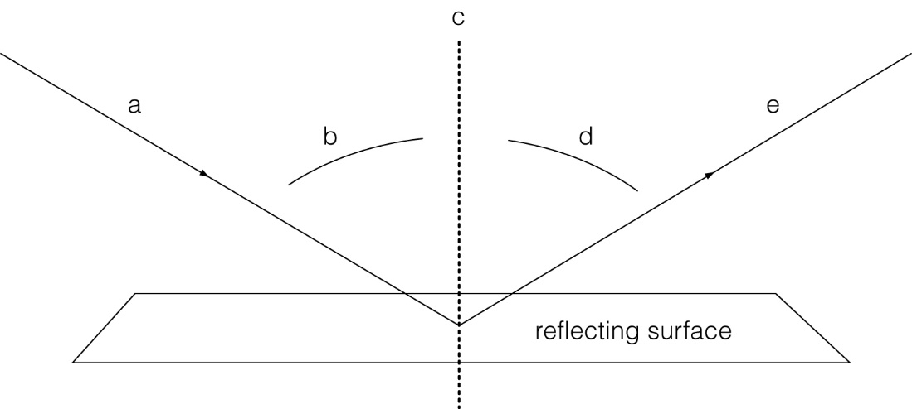

(a) _____________________________________________________

(b) _____________________________________________________

(c) ______________________________________________________

(d) ______________________________________________________

(e) ______________________________________________________

2. Write a statement comparing the angles of incidence and reflection.

________________________________________________________

________________________________________________________