Lenses
Focus:
- To be able to describe the difference between a lens and a mirror
- To be able to describe the difference between a concave and convex lens
- To be able to describe the image formed through a concave and a convex lens
- A lens is a curved ____________________________ material that refracts (_________) light.
Concave Lenses
- Concave lenses are lenses that are _____________________ in the middle than at the edges. Light rays that pass through a ___________________________ lens diverge (_______________)
- The image formed is always _____________________ and smaller than the actual object.
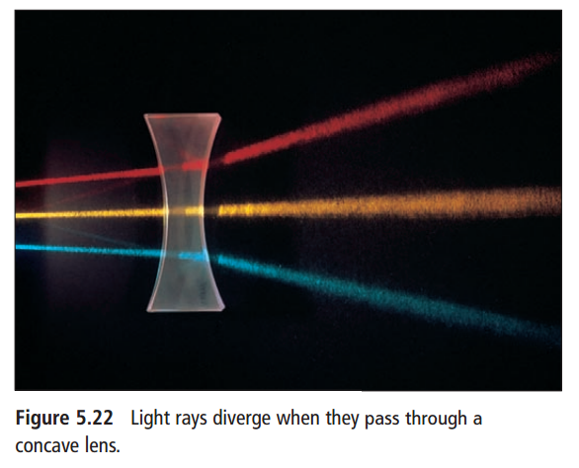
In Summary
Distance of Object from Lens | Type of Image Formed
Any location
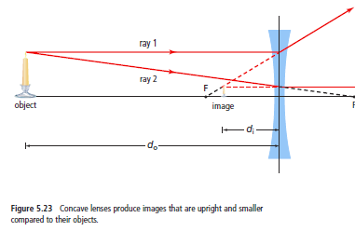

Convex Lenses
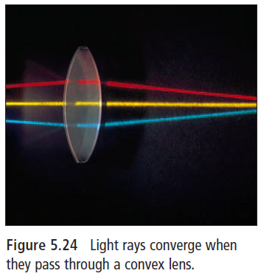
- Convex lenses are lenses that are __________________ in the middle than at the edges. Light rays that pass through a ____________________ lens will converge (_____________________)
- The image from a convex lens can be __________________________ or upright depending on the position of the object.

- Whether an image is upright or upside down will depend on how close it is to the lens
  - Focal length: The ____________________ from the centre of the ____________ or mirror to the focal point

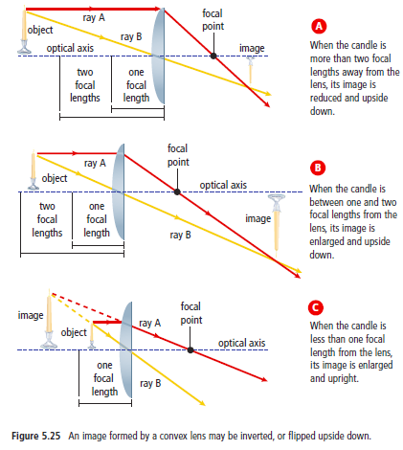
In Summary:
Distance of Object from Lens | Type of Image Formed
More than two focal lengths
Between one and two focal lengths

Object at focal point

Less than one focal length

