States of Matter
Focus:
- To be able to define the terms matter, mass, volume, heat, and thermal energy
- To be able to explain the kinetic molecular theory
- To be able to describe the different states and states of change

- Matter is anything that has mass and __________________________
- Mass is the quantity of ___________________ that a substance contains, measured in grams (g) or kilograms (kg)
- Volume is the amount of ____________________ taken up by a substance, measured in milliliters (mL), liters (L), or cubic centimeters (______)

Think-pair-share
- Recall from earlier studies that there are 3 states of matter. Define the 3 state of matter and give examples of each:

The three familiar states of matter:
 | Fixed mass | Fixed Volume | Fixed Shape
Solid
Liquid
Gas
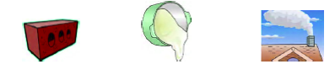
The Particle Model of Matter
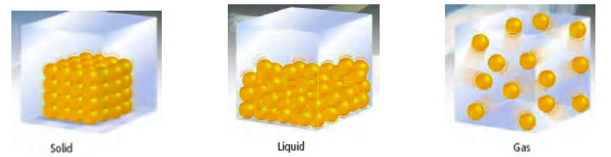

- All ____________________ is made up of very small ________________________.
- There are __________________ between the ____________________. (___________________
_____________________________________________________________________________.)
- The ____________________ that make up matter are always ____________________.
- The ____________________ are always ____________________ to one another. (___________
_____________________________________________________________________________.)

Kinetic Molecular Theory
- All matter is made up of very small ______________________ (atoms and molecules)
- There is _______________________ space between particles
- Particles are constantly moving. The particles are ___________________________ with each other and the walls of the container
- ____________________ makes particles move. The more energy the particles have, the faster they can move and the __________________ apart they can get.

 | Solid | Liquid | Gas
Spaces between particles
Particle movement
Diagram

Thermal Expansion and Contraction
- When you add ______________________ energy to a material, you increase the kinetic energy of the particles.
- As the temperature _________________________, the particles move faster, spreading over a larger region, resulting in thermal expansion of the material.
- Thermal contraction results when a material cools and the movement of the particles ____________________, taking up less space.

Heat and Temperature
- The _______________________ energy of all the particles of a substance is called thermal energy
- Heat is the energy transferred from one type of matter to another as a result of a difference in ______________________________________
- Temperature is the _________________________________ kinetic energy of the particles in a substance.

Think-pair-share:
How does matter change as temperature increases? Decreases?
(Consider the behaviour of the particles and the space between particles.)

Changes of State
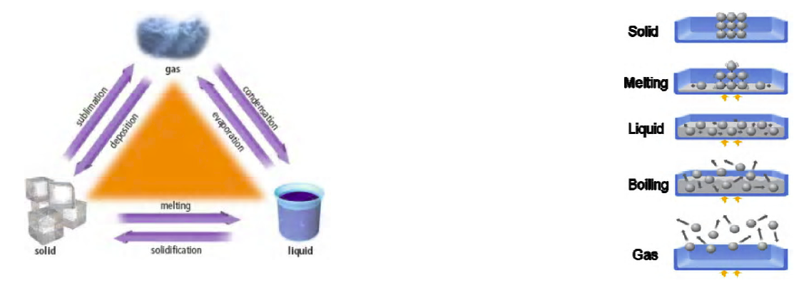
Name | Change of State  (from ____ to ____) | Heat Gained | Heat Lost
Melting | Solid to Liquid
Evaporation
 | Gas to Liquid
 | Solid to Gas
Deposition
Solidification

