Name: ______________________ Class: _____ Date: ___________________

The Atom: Introduction but Also Review

- What is the basic building block of all matter in the world? What are these basic building blocks made up of?

- What is the name for the center of the atom containing the protons and neutrons?

- What kinds of electrical charges do protons, electrons, and neutrons have?

- What causes the particles of the atom to stay together?

- Identify the following subatomic particles:

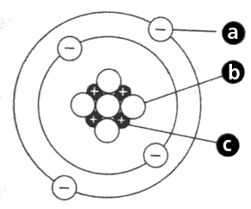

a: ____________________________

b: ____________________________

c: ____________________________

What do you recall from Static Electricity last year?

- What does it mean if an entire atom has a neutral charge?

- What can happen to the atomic particles when you rub two objects together?

- What happens to an object that loses electrons?

- What happens to an object that gains electrons?

- What happens to an object with a positive charge and an object with a negative charge?

- What happens to two objects with the same charge? (Ex. two positive or two negative charges)

