Name: | Class: | Date:

Science 8: Physics Review

Use your textbook and notebook to help you answer the questions in this review package.

4.1 Properties of Waves

- On the wave below, label the crest, trough, wavelength, and amplitude.

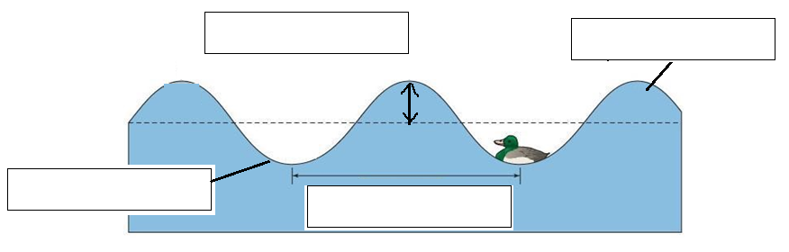

- Define the following terms:

  - Energy ______________________________________________________________
  - Frequency ____________________________________________________________
  - Medium _____________________________________________________________

- What is the difference between a transverse wave and a compression wave? Draw a diagram of each.

___________________________________________________________________________
___________________________________________________________________________

- Write out the formula for frequency. What is the frequency of a pendulum that swings back and forth 20 times in 4 seconds? Don’t forget your units!

4.2 Properties of Visible Light

- What is the wave model of light?

______________________________________________________________________________________________________________________________________________________
- What is refraction?

_________________________________________________________________________________________________________________________________________________________________________________________________________________________________
- What colours make up white light?

___________________________________________________________________________
___________________________________________________________________________
- Each colour that makes up white light travels with a different wavelength. Put the seven colours in order of longest wavelength to shortest wavelength.

- What is reflection?

_________________________________________________________________________________________________________________________________________________________________________________________________________________________________

6. There are three additive primary colours and these colours make up the secondary colours. a. What are the three additive primary colours?

__________________________________________________________________________

b. Name the three secondary colours and name the two colours that make up each secondary colour.

__________________________________________________________________________

__________________________________________________________________________

__________________________________________________________________________

4.3 Light and the Electromagnetic Spectrum

- Label the diagram below with the terms: gamma rays, infrared waves, microwaves, radio waves, ultraviolet waves, X rays.

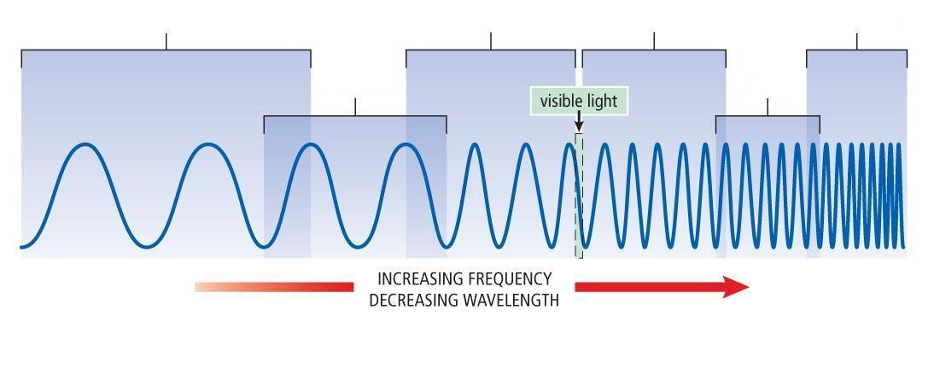

- Name the waves that have a longer wavelength than visible light.

___________________________________________________________________________

- Name the waves that have a shorter wavelength than visible light.

___________________________________________________________________________

- Which wavelength is:
  - longest?___________________________________________________________

  - shortest?__________________________________________________________

5.1 The Ray Model of Light

- What is the Ray Model of Light?

______________________________________________________________________________________________________________________________________________________

- Compare how light travels through a material that is:

  - transparent ___________________________________________________________
  - translucent ___________________________________________________________
  - opaque ______________________________________________________________

- State the Law of Reflection. Draw a diagram that illustrates the Law of Reflection that includes incident ray, reflected ray, angle of reflection, angle of incidence, and normal.

______________________________________________________________________________________________________________________________________________________

- The diagram below shows how light moves in water and air.
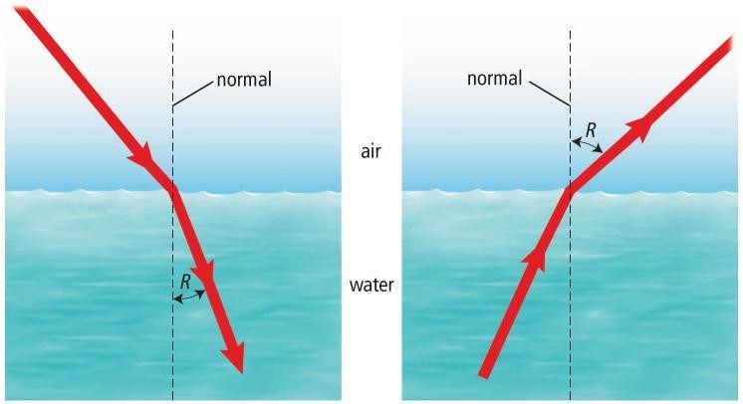

  - What substance is denser: air or water? _____________________________________

  - What substance does light travel through faster: air or water? ___________________

  - The angle between the refracted ray and the normal is the angle of ______________ .

In the following questions circle the correct terms that complete each sentence.

  - When light travels into a denser substance, light speeds up / slows down and bends towards / bends away from the normal.

  - When light travels into a less dense substance, light speeds up / slows down and bends towards / bends away from the normal.

5.2 Using Mirrors to Form Images

- Name the three types of mirrors.
__________________________________________________________________________
______________________________________________________________________________________________________________________________________________________

- Concave mirrors produce reflected rays that converge.

  - When the object is near the mirror, the image is ________________ and ______________

  - When the object is far from the mirror, the image is ________________ and ______________

- Convex mirrors produce reflected rays that diverge.

  - The image is always ________________ and _______________

  - Why are convex mirrors used as security mirrors?
____________________________________________________________________
________________________________________________________________________________________________________________________________________________

5.3 Using Lenses to Form Images

- Draw a diagram showing three incident rays passing through a concave lens.

- What type of image is formed from a concave lens?

___________________________________________________________________________

- Draw a diagram showing three incident rays passing through a convex lens.

6.1 Human Vision

- Name the function of the parts of the eye:

  - pupil: ____________________________________________________________
  - iris: ______________________________________________________________
  - cornea: ___________________________________________________________
  - lens: _____________________________________________________________
  - sclera: ____________________________________________________________
  - retina: ____________________________________________________________
  - optic nerve: ________________________________________________________

- Where is the blind spot in the eye?
______________________________________________________________________________________________________________________________________________

- What are rod cells?
______________________________________________________________________________________________________________________________________________

- What are cone cells?
______________________________________________________________________________________________________________________________________________

- What causes people to be near-sighted? What causes people to be far-sighted?

______________________________________________________________________________________________________________________________________________

______________________________________________________________________________________________________________________________________________

- Label the parts of the eye:
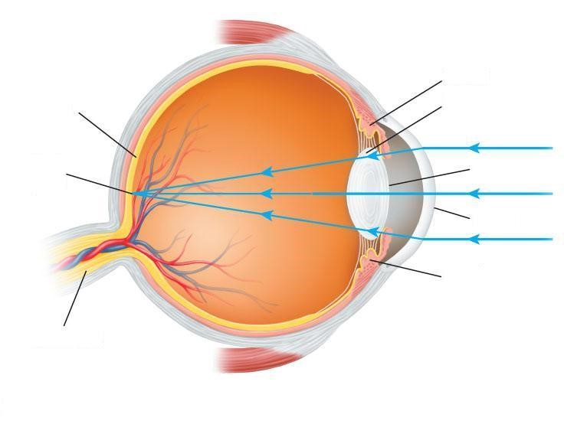

7. Using the diagram below, draw the corrective lens that would correct hyperopia. Draw the adjusted light rays that would result.
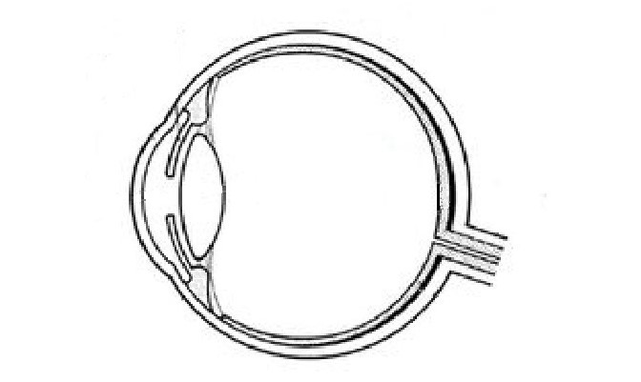
State the type of lens that is used to correct hyperopia and what happens so that vision is clear.

____________________________________________________________________________________________________________________________________________________________________________________________________________________________________________________________________________________________________________

