Name: | Class: | Date:

Science 8: Chemistry Review

Use your textbook and notebook to help you answer the questions in this review package.

7.1 States of Matter

- Matter is made up of what two properties?

______________________________________________________________________________ ______________________________________________________________________________

- State the three states of matter and draw a diagram that shows how differently the particles in each state move.

- State the four points of the Kinetic Molecular Theory.

  - _____________________________________________________________________

  - _____________________________________________________________________

  - _____________________________________________________________________

  - _____________________________________________________________________

- What is kinetic energy?

____________________________________________________________________________________________________________________________________________________________

- State the four points of the Particle Model of Matter.

  - _____________________________________________________________________

  - _____________________________________________________________________

  - _____________________________________________________________________

  - ____________________________________________________________________

- The diagram below shows the different changes of state. Fill in each box with the correct term.
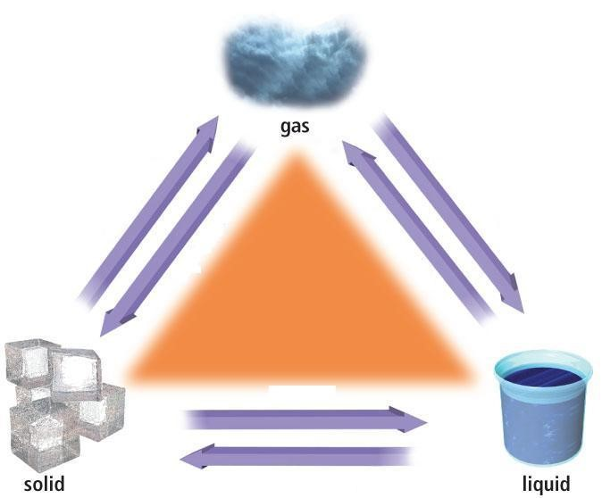

- When particles move faster in an object, what happens to:

  - the temperature of the object? __________________________________________

  - the volume the particles occupy? ________________________________________
7.2 Fluids and Density

- Write out the formula for density.

- Define the term “fluid”.

____________________________________________________________________________________________________________________________________________________________

- The diagram below shows three layers of fluids:

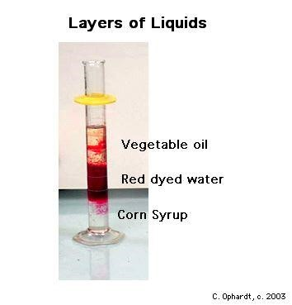

  - Which layer is the densest? ___________________________

  - The density of the three liquids are: 1.5 g/mL, 0.75 g/mL, and 0.90 g/mL. Match up the density with the liquid.

- Vegetable oil ________

- Red dyed water ________

- Corn syrup __________

- What is the difference between thermal expansion and contraction and when does each occur?

_______________________________________________________________________________________________________________________________________________________________________________________________________________________________________

Calculating Density – Practise:

- Use the given measurements to calculate density:

- Mass = 7.2 g, volume = 3 cm³

- Mass = 520 g, volume = 2 mL

- Mass = 6300 g, volume = 9 L

- A metal sample has a mass of 35000 g and a volume of 4.0 cm³. What is the density of the metal?

- A metal sample with a mass of 1498 g occupies a volume of 70 cm³. Use the table below to identify the metal. (Recall, 1 cm³ = 1 mL)

Type of metal | Density
Gold | 19.3 g/mL
Iron | 7.9 g/mL
Silver | 10.5 g/mL
Platinum | 21.4 g/mL

The metal is ________________________

7.3 The Atomic Model

- a) Draw and label an atom

b) List the 3 subatomic particles & describe their charge, size, and location in an atom.
____________________________________________________________________________________________________________________________________________________________________________________________________________________________________________________________

- Describe the difference between atomic number, mass, and weight.

__________________________________________________________________________________________________________________________________________________________________________________________________________________________________________

- What subatomic particle is gained or lost to create ions? ____________________________

- Why does the atomic number and mass not change in an ion?

____________________________________________________________________________________________________________________________________________________________

